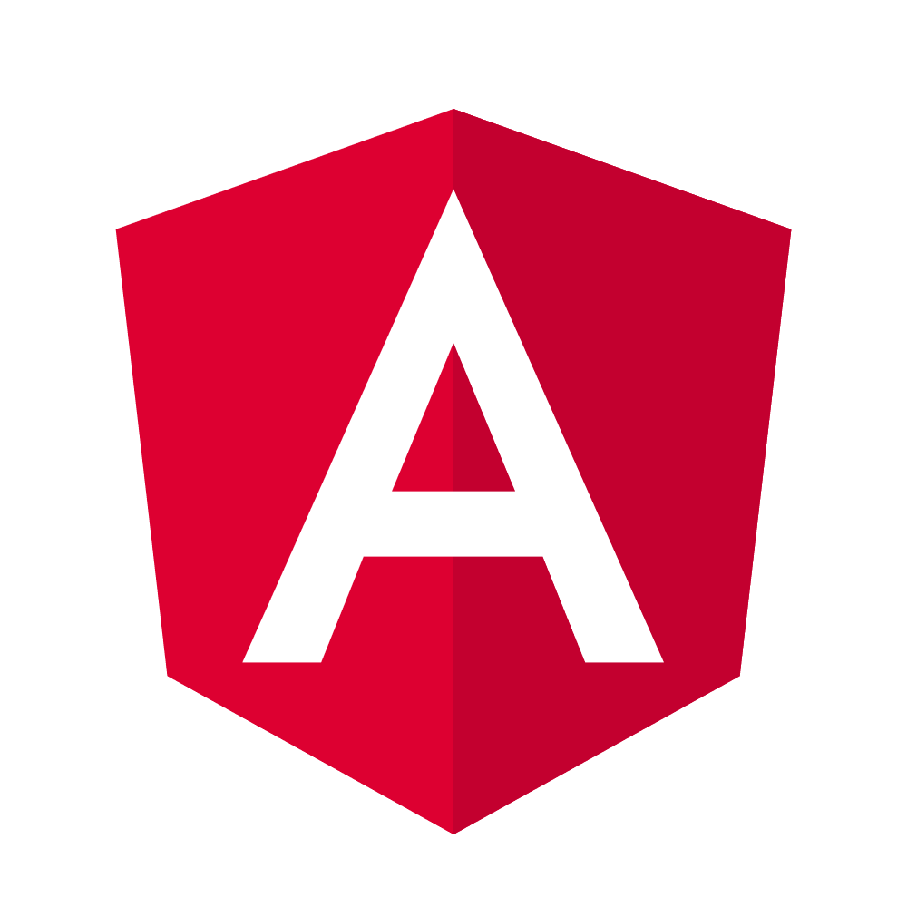

Angular 15
Vivekanand P V

Aim:
- To gain working understanding of the modern component-based front-end design using Angular framework
- To gain deeper understanding of the core Angular framework
- To learn best practices of Angular application development

Duration:
3 days (standard content)

Prerequisites:
- Hands-on experience in HTML, CSS, and JavaScript
- Understanding of software engineering principles
- Knowledge of standard design patterns is a bonus

Essential Reading:
The aim of essential reading is to bring participants quickly to the pace. Participants are required to go through these quick guides before attending the training.

- JavaScript basics: https://developer.mozilla.org/en-US/docs/Learn/Getting_started_with_the_web/JavaScript_basics
- TypeScript basics: https://www.typescriptlang.org/docs/handbook/typescript-in-5-minutes.html
- DOM (Document Object Model) basics: https://developer.mozilla.org/en-US/docs/Web/API/Document_Object_Model/Introduction

Lab Setup:
Classroom Training | Virtual Training
- HD-quality projector or screen with HDMI connectivity  - Whiteboard and markers | Access to (one of):  - Zoom Meeting  - Skype  - Google Meet (Hangout)  - Microsoft Teams

Environment Setup:
- Access to internet and Npm repository
- Please refer to Angular tool setup guide (Annexure 1) to setup the tools required for Angular development
- Please refer to the developer environment setup guide (Annexure 2) for setting up Visual Studio Code with necessary extensions
- Access to GitHub so that participants can clone/download/refer to sample and reference code
- Access to Angular documentation and other online resources

Content

Day 1
Session 1
Angular project anatomy
Angular components and composition
Value binding
Pipes
DOM and Angular
Property binding
Hands-on exercises

Session 2
Custom property binding
Angular event binding semantics
DOM event binding
Custom events
Built-in directives
Hands-on exercises

Day 2
Session 1
Life-cycle hooks
Angular services
Introduction to reactive programming using RxJS
Building reactive pipelines
Dependency injection in Angular
Custom configuration of dependencies
Hands-on exercises

Session 2
Http communication
Working with Http headers
Environment objects
Automatic subscription (async pipe)
Reactive forms
Validation in reactive forms
Hands-on exercises
Day 3
Session 1
Routing
Routing directives
Router parameters and query
Navigation extras
Link and programmatic navigation
Feature modules and Lazy Loading
Hands-on exercises

Session 2
RxJS Essential Operators
Angular Dependency Injection
Global and local styles
Introduction to Angular Material
Hands-on exercises
Angular build process
Understanding Angular artifacts
Containerization of Angular apps (demonstration)
Q & A
Review
Tips and Tricks
Further Reading
Conclusion

Annexure 1: Essential Set-up Guide for Angular Training
- Install the editor and Node.js runtime
  - Visual Studio Code (v1.70 or higher): https://code.visualstudio.com/
  - Node.js (v18): https://nodejs.org/en/
- Ensure the versions of Node.js and npm (in the command prompt)
- node --version //should be v18
- npm --version //should be 9 or higher
In case the versions are lower, you may have an older Node.js runtime installed. Try uninstalling the older version and installing the current version of Node.js (v18 as on February 2023). Once you have completed the reinstallation, please ensure the versions. Node v19 (current) is not recommended for Angular.
- Install the Angular CLI
npm install -g @angular/cli

- Ensure the version of Angular CLI
ng version //should be 14 or higher
- In case the Angular CLI version is lesser, you may run the cli installation command once again (step c)
- A common error in Windows PowerShell is “…ng.ps1 cannot be loaded because the execution of scripts is disabled on this system.” To resolve, run PowerShell as an administrator, and run:
Set-ExecutionPolicy -Scope CurrentUser Unrestricted

- Install extensions in Visual Studio Code
  - Prettier Code Formatter (by Prettier)
  - Angular Language Service (by Angular)
- Follow the steps in the editor setup guide

Annexure 2: Visual Studio Code Customization

- Open Settings: File > Preferences > Settings

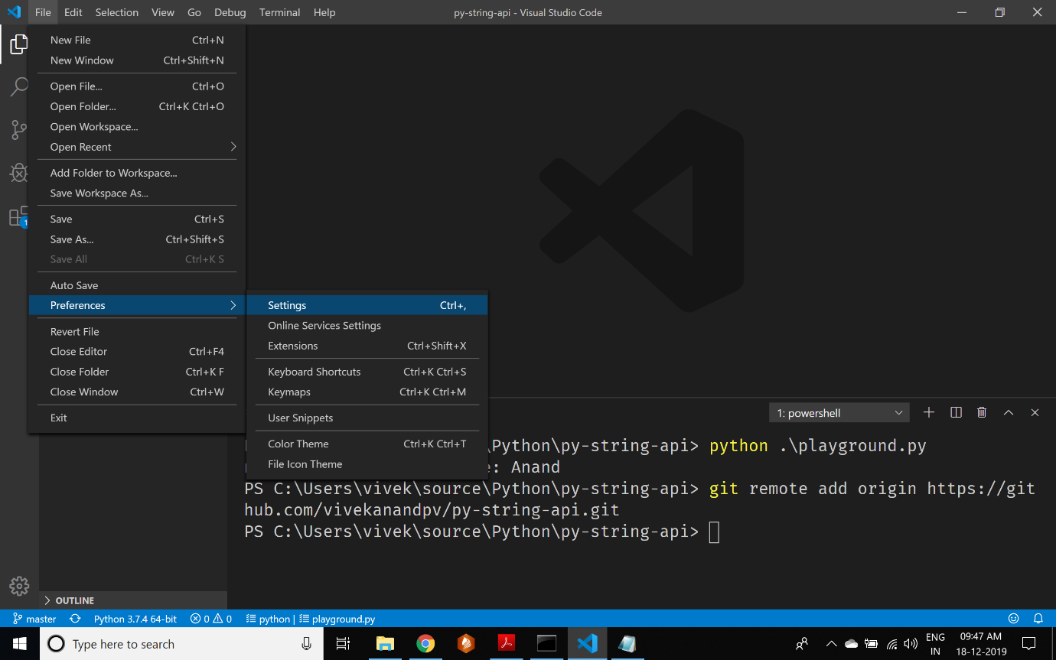

- Increase font size to 20

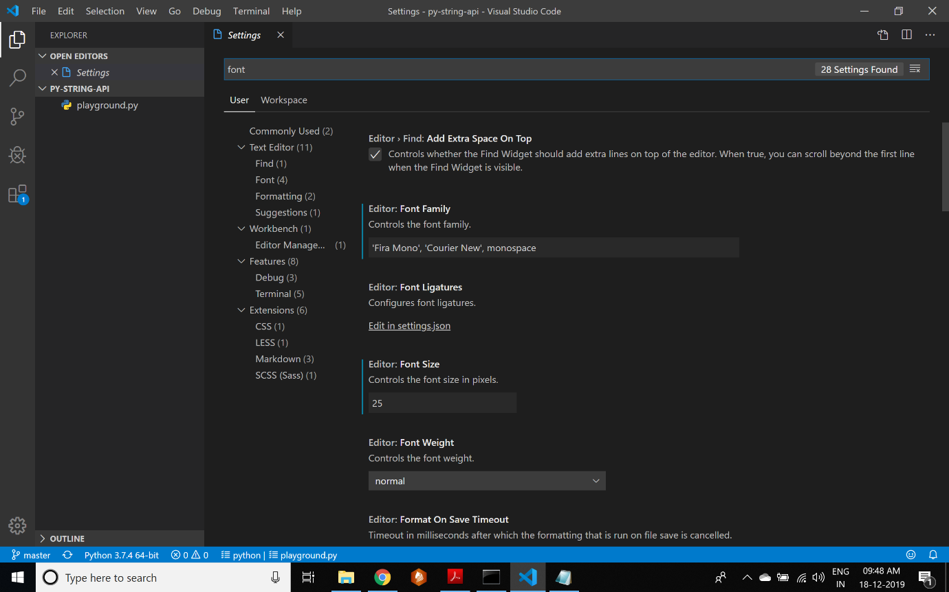
Search for font
Make it 20

- Turn on Format on Save and Format on Paste

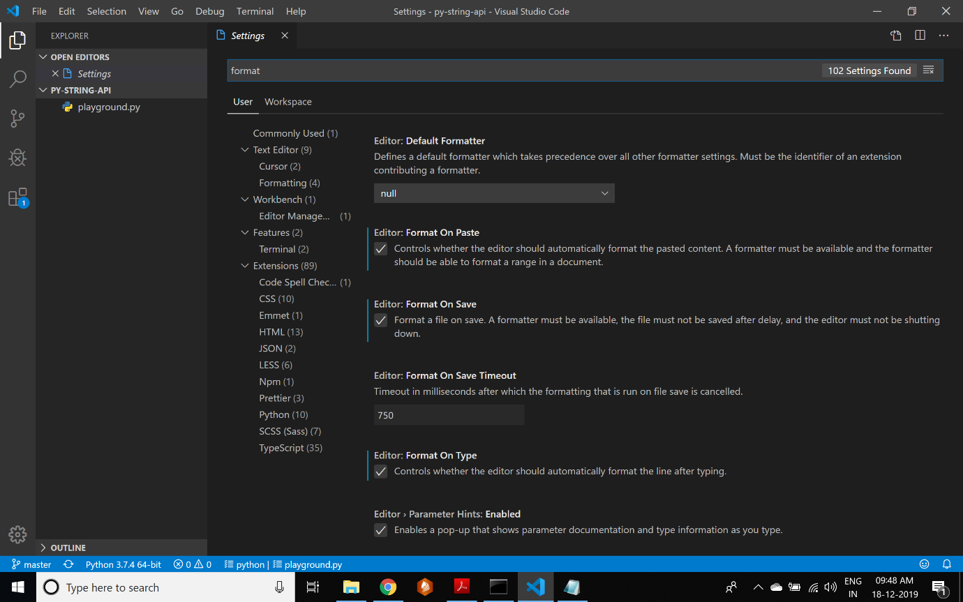
Search for format

- Customize the quote style
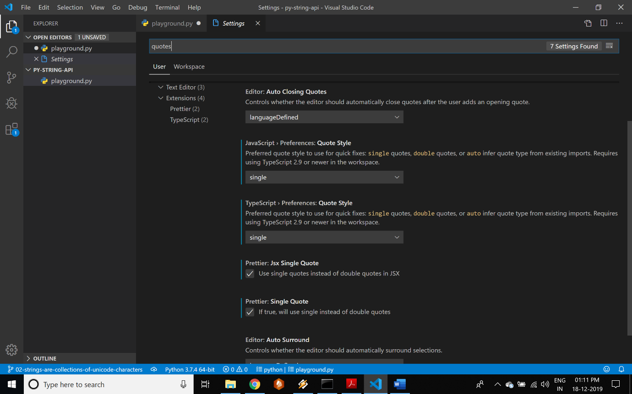
Search for quotes

